Report Template (FYP1).
Table of contents:
Abstract: # ** 0

Chapter 1 - Introduction
1.1 Project Background: # ** 0
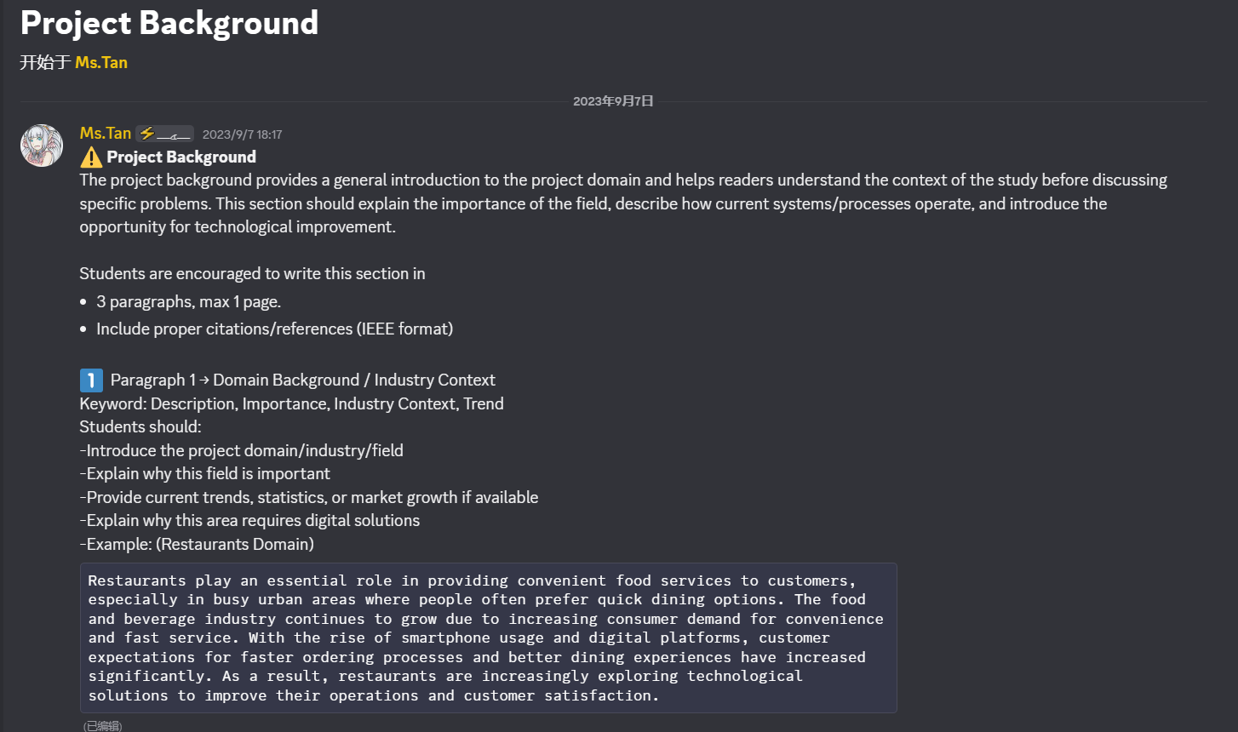
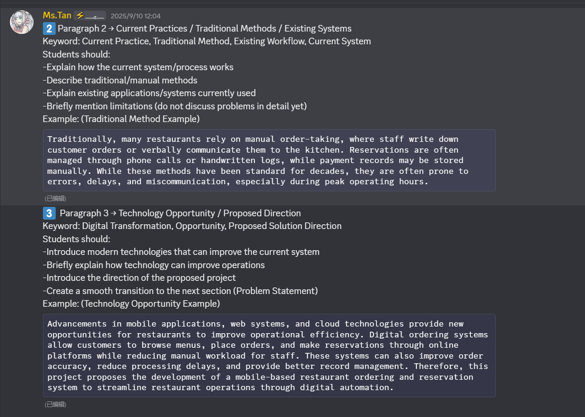
1.2 Problem Statement and Motivation: # *0
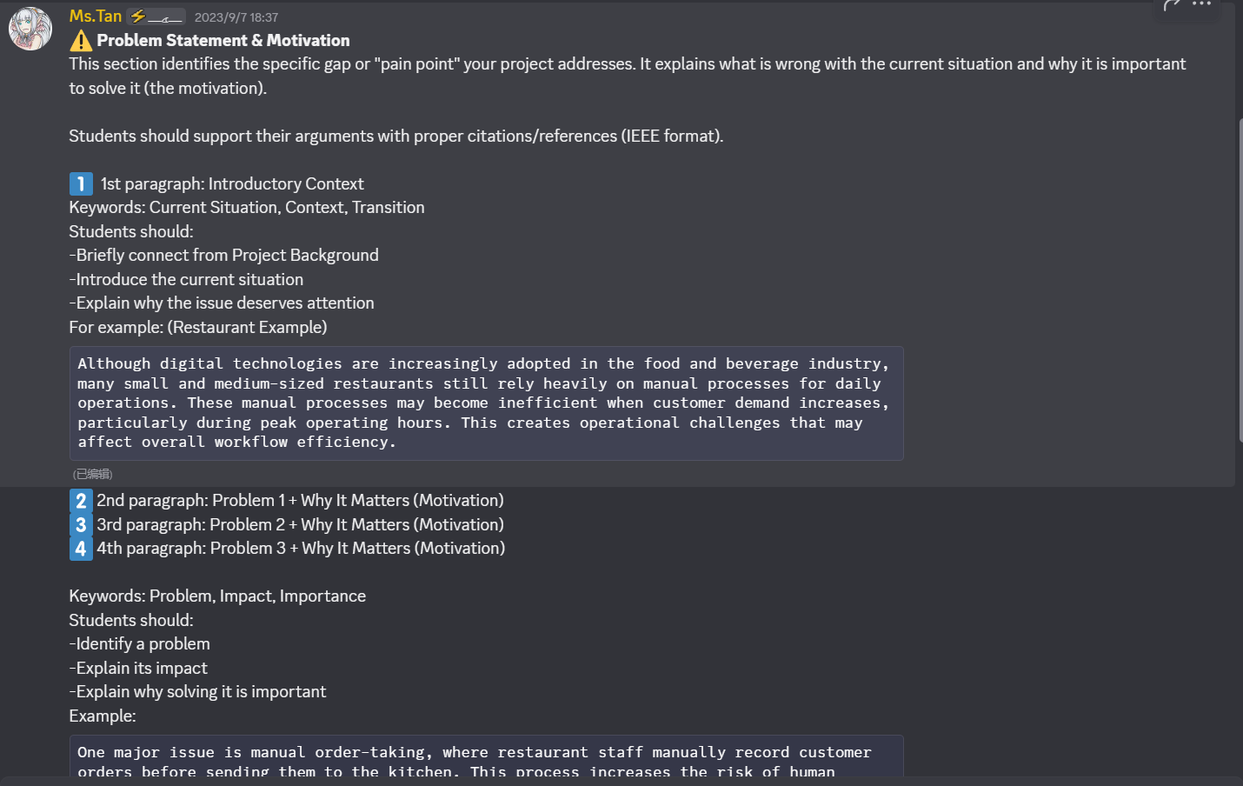
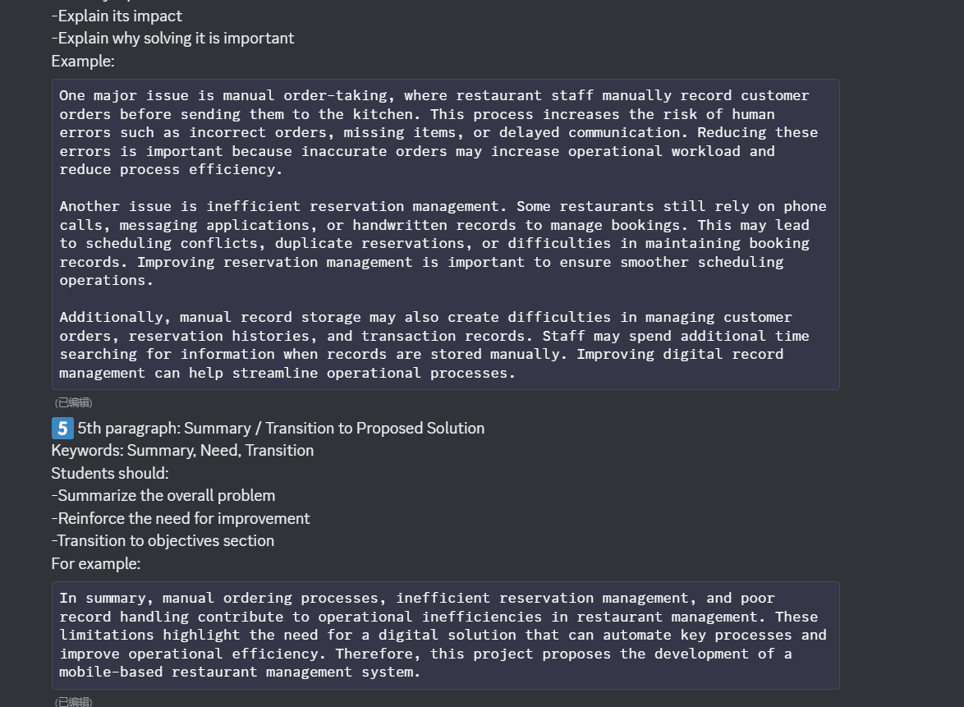
1.3 Project Objectives: # ** 0
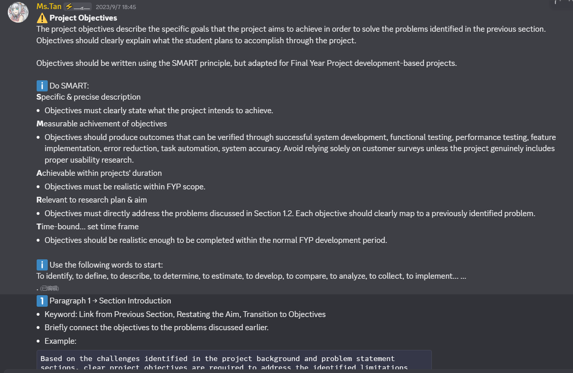
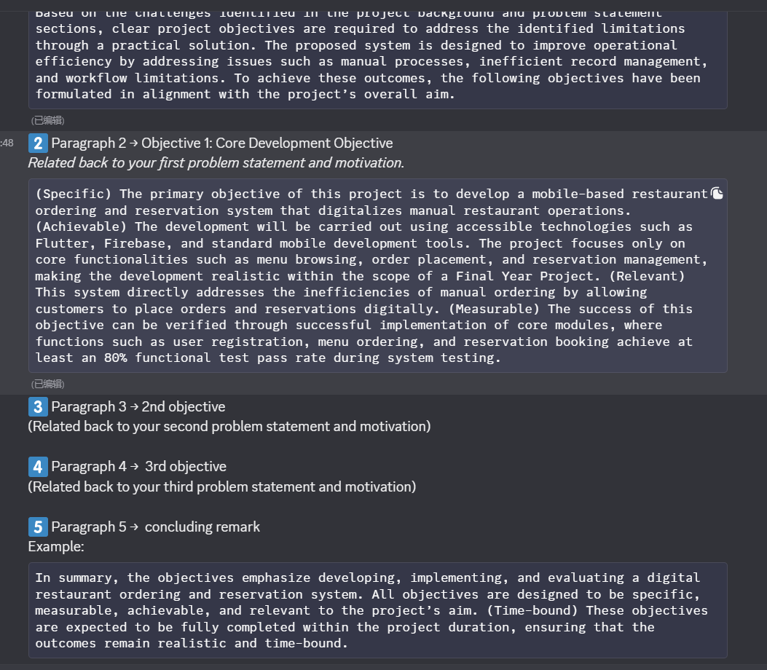
1.4 Project Contribution: # ** 0
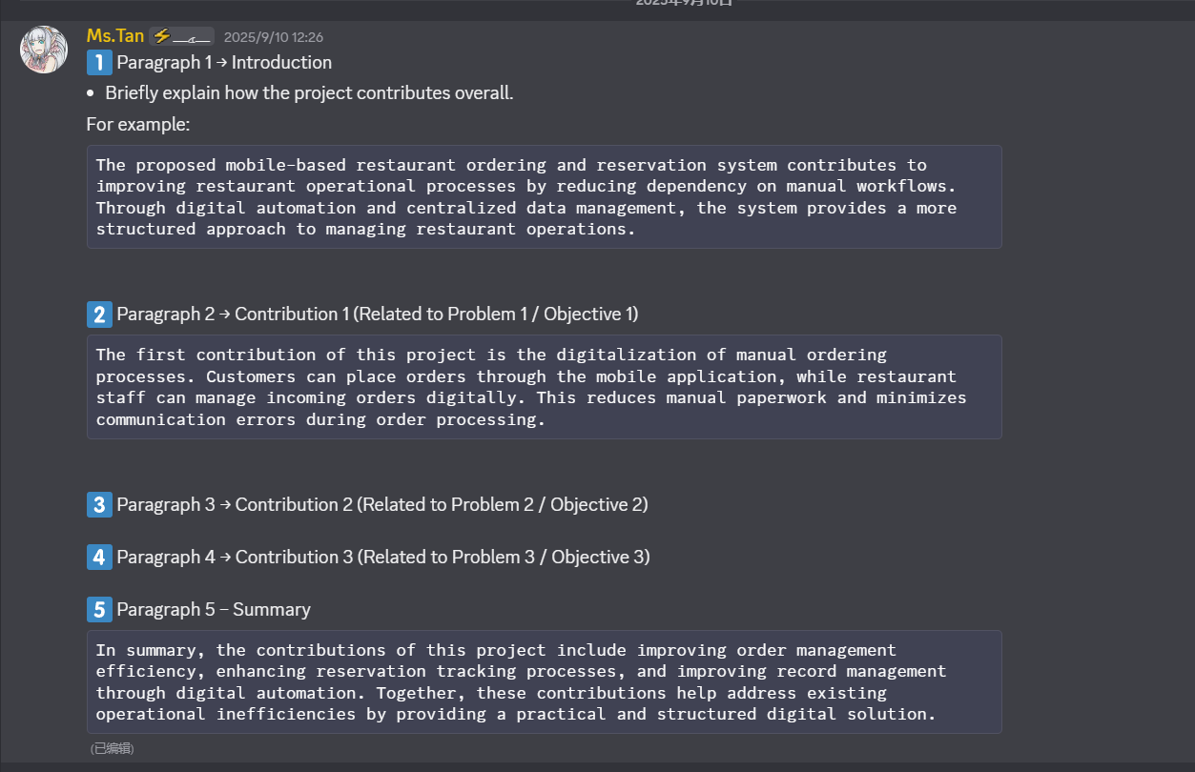
1.5 Project Scope: # 未知
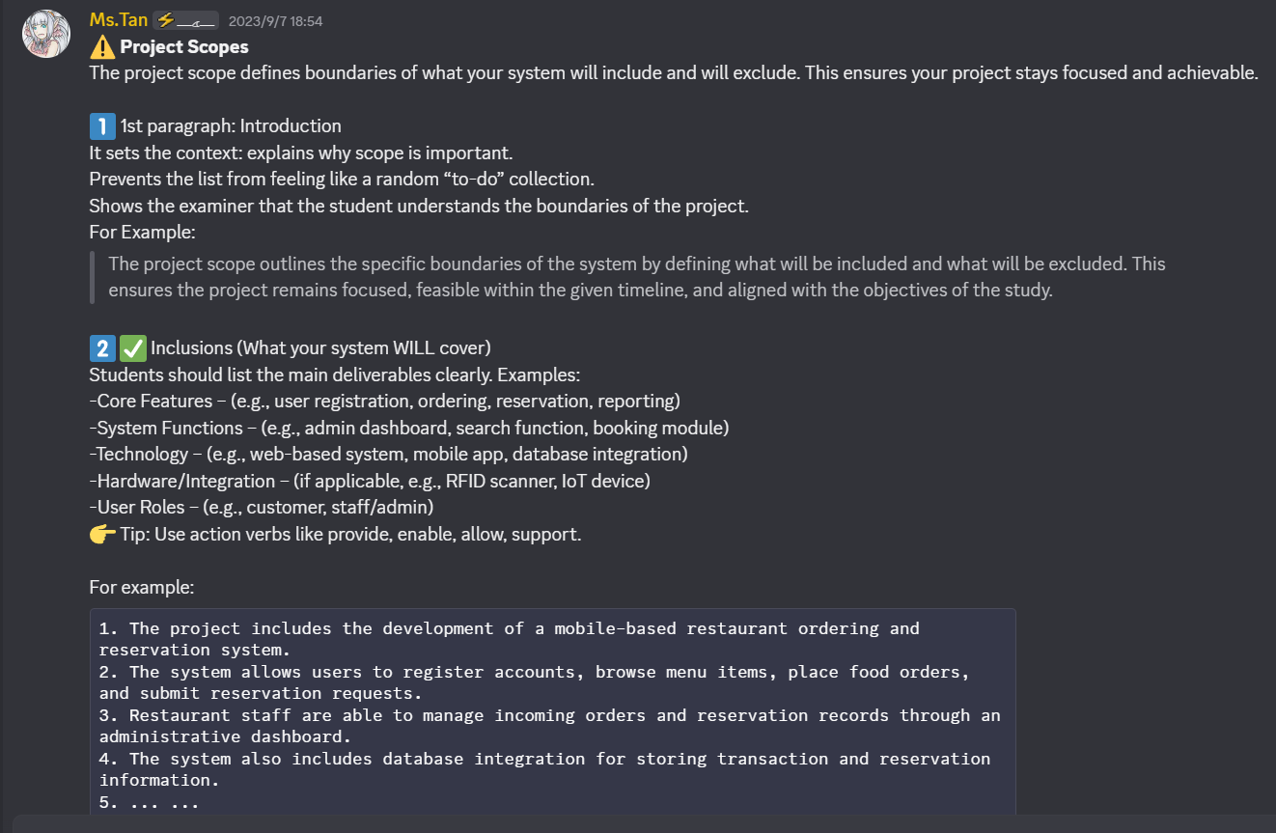
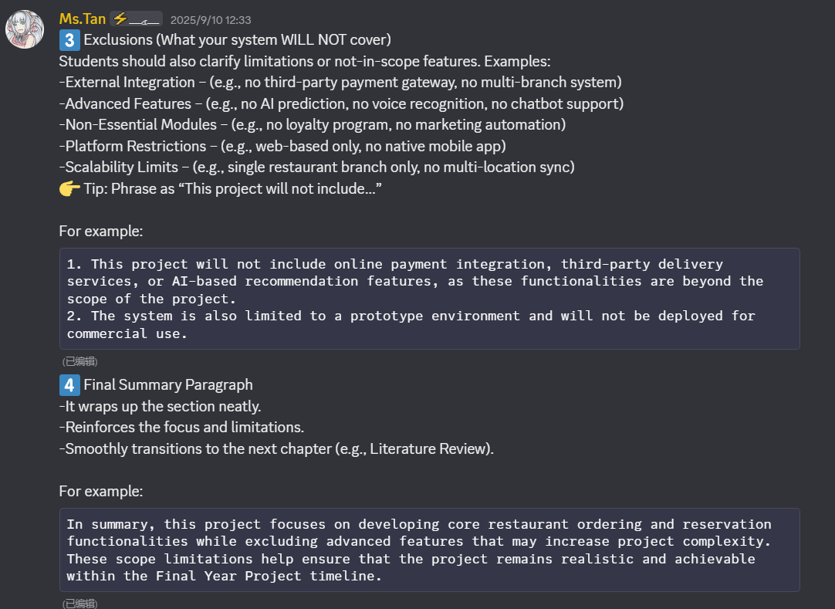
1.6 Report Organization

Chapter 2 - Literature Review
Literature Review: # ** 0
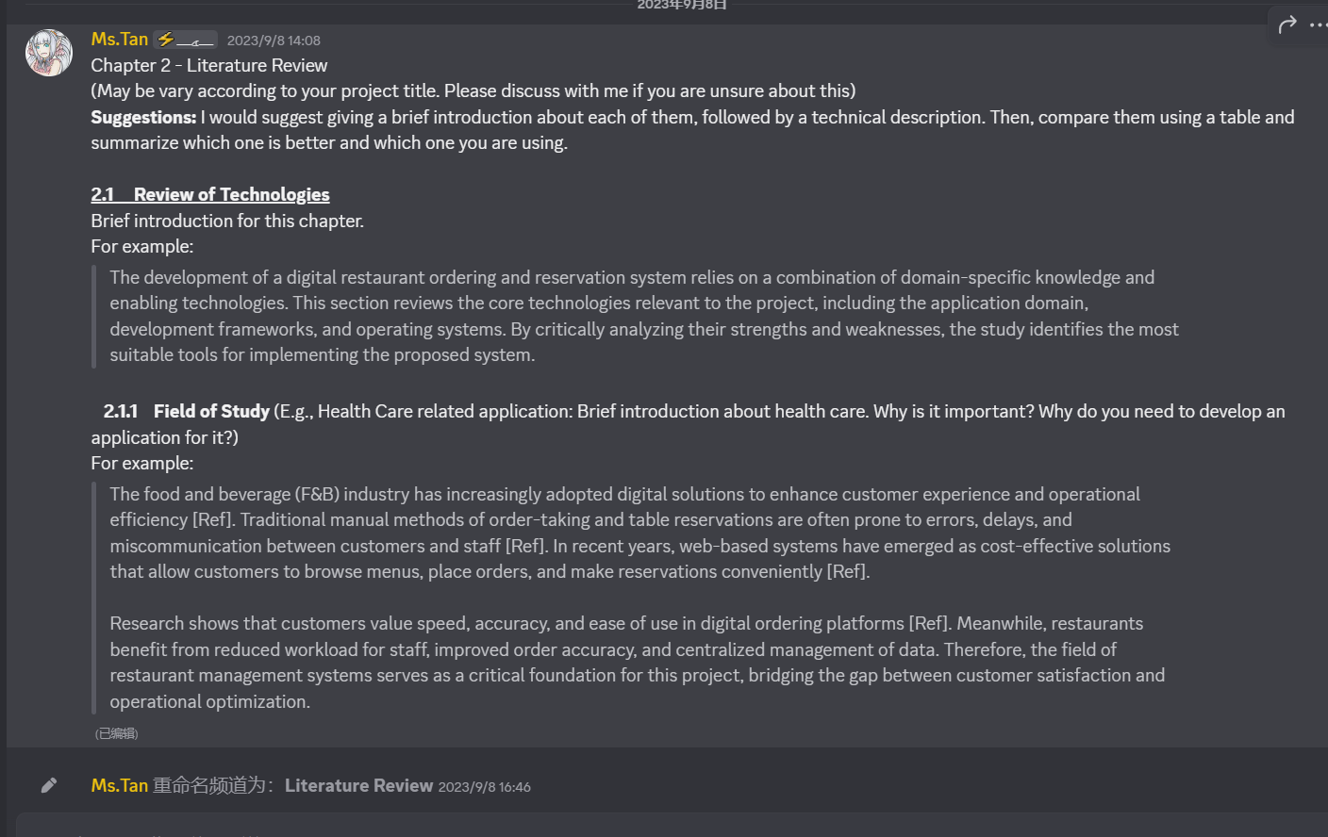
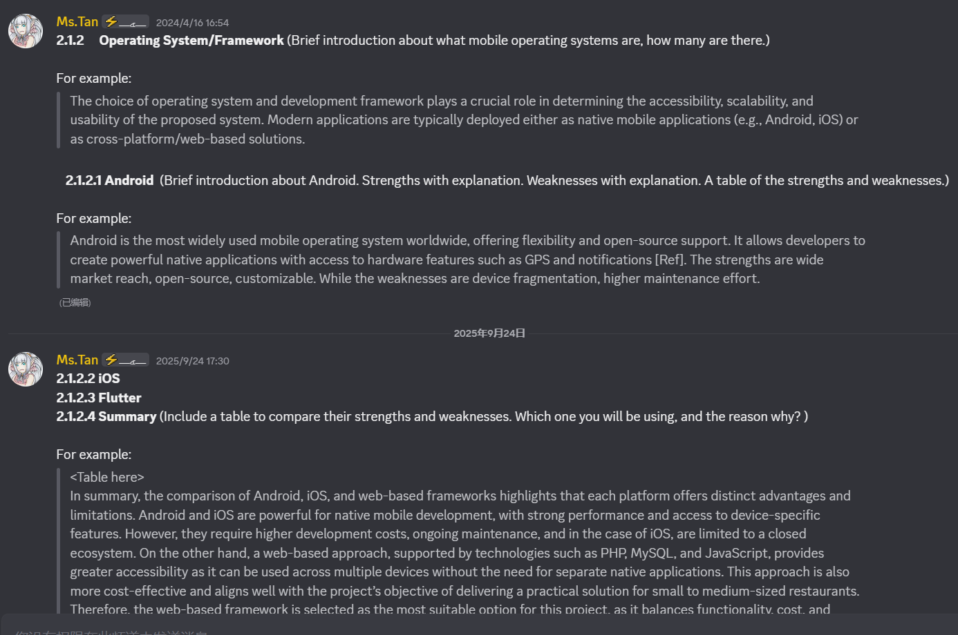
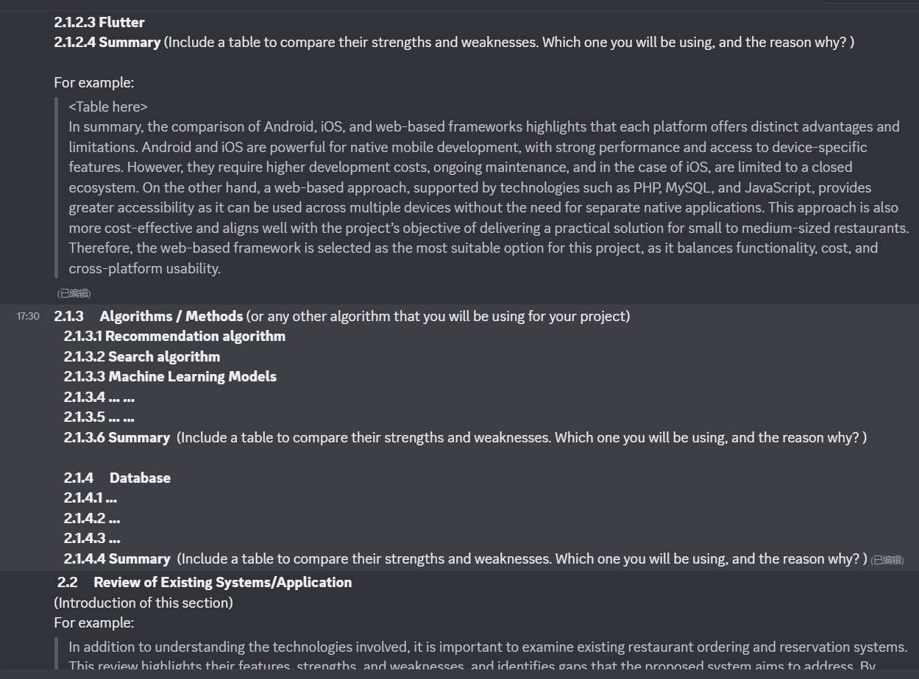
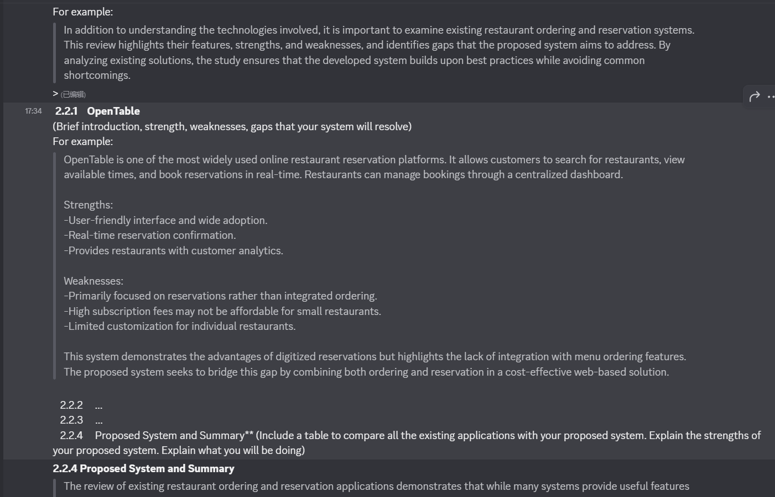
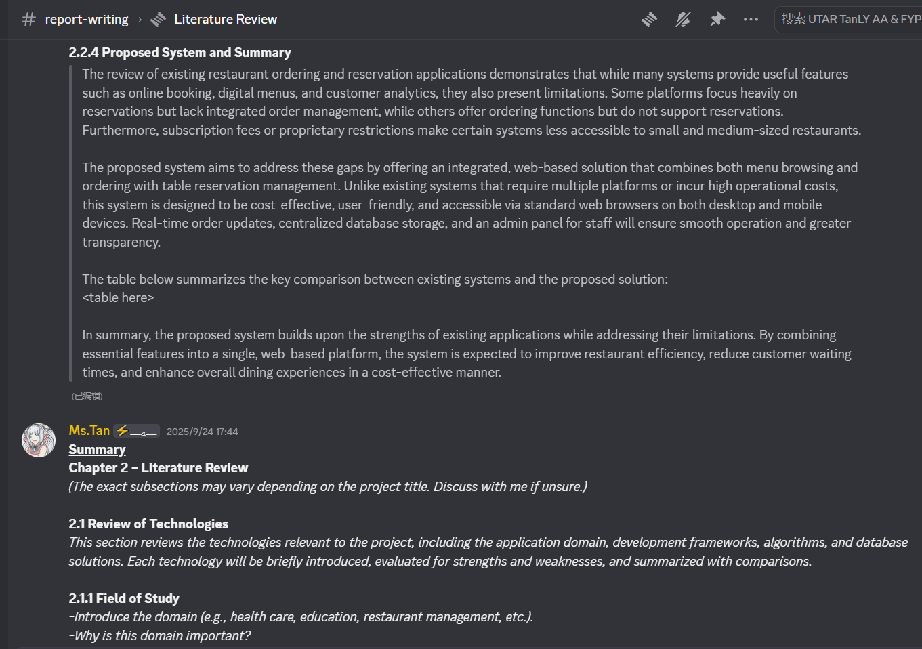
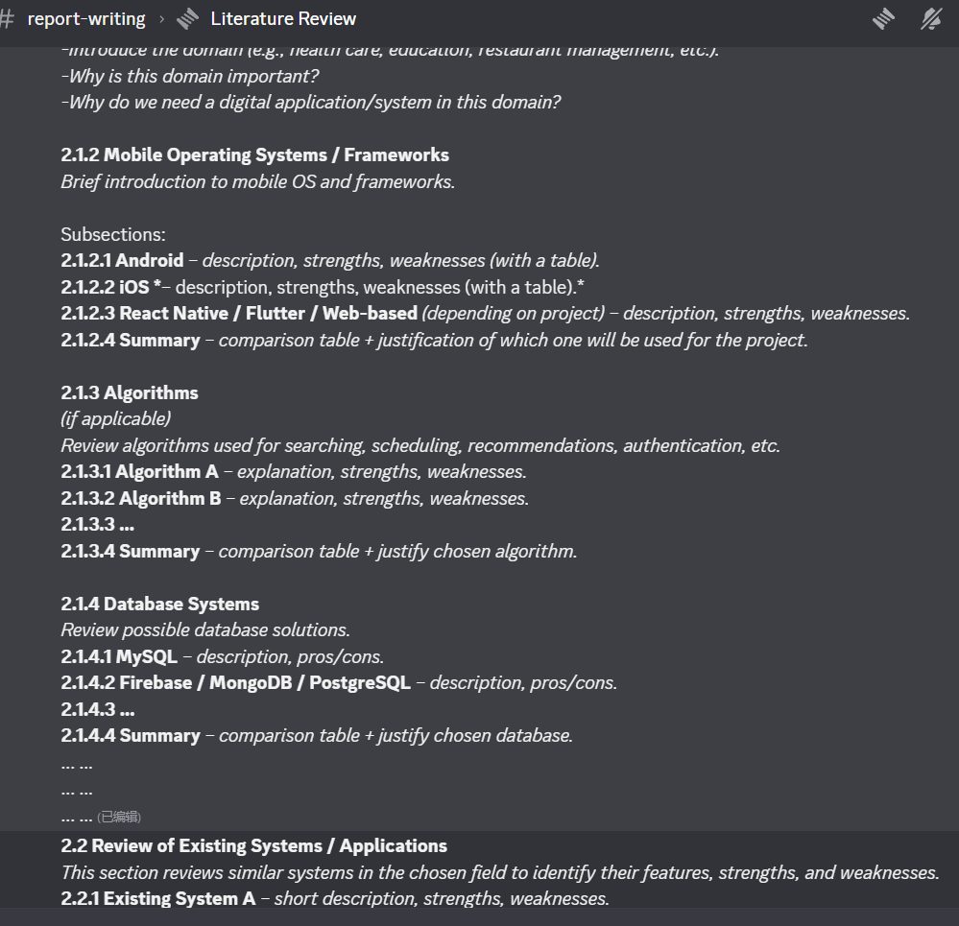
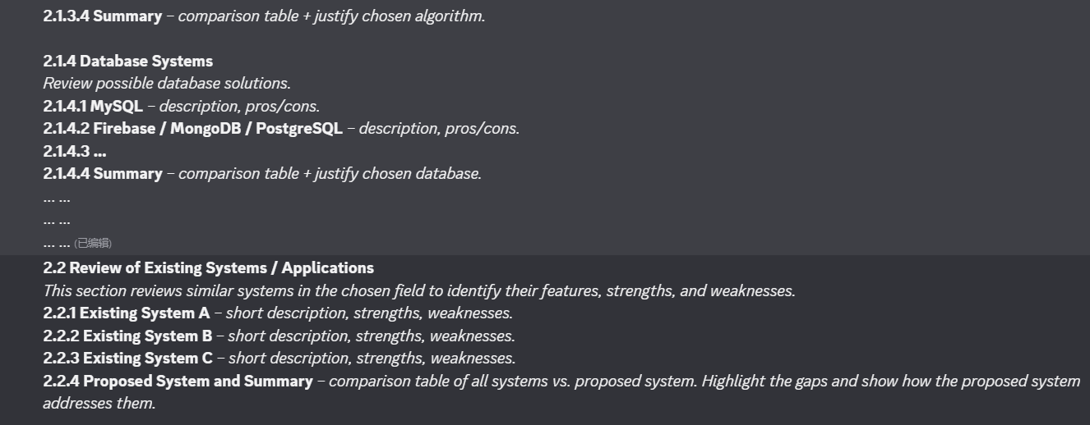
Chapter 3 - System Methodology
3.1 System Development Models: # ** 0
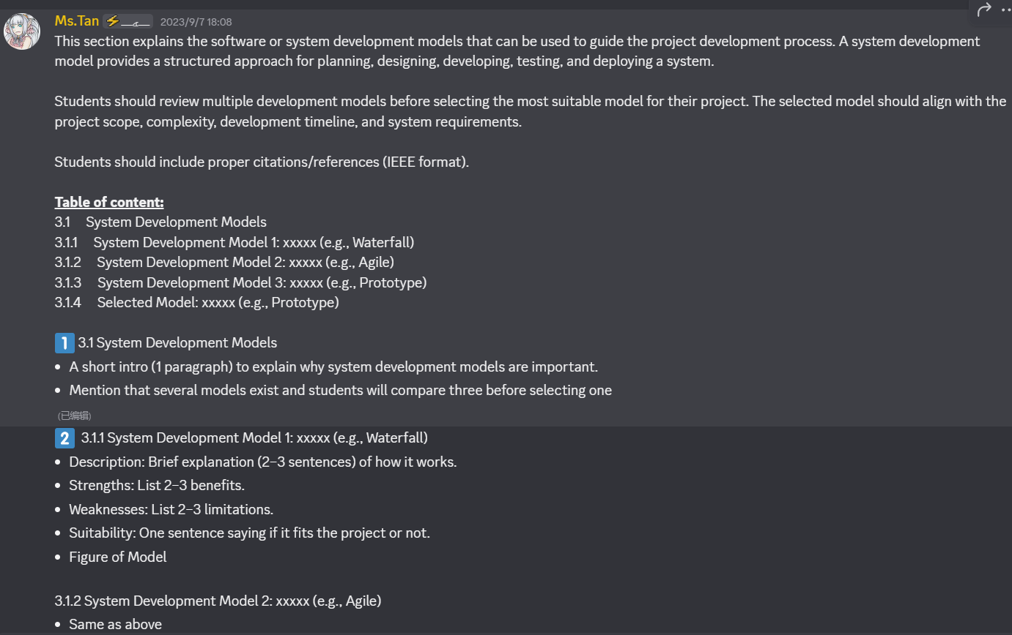
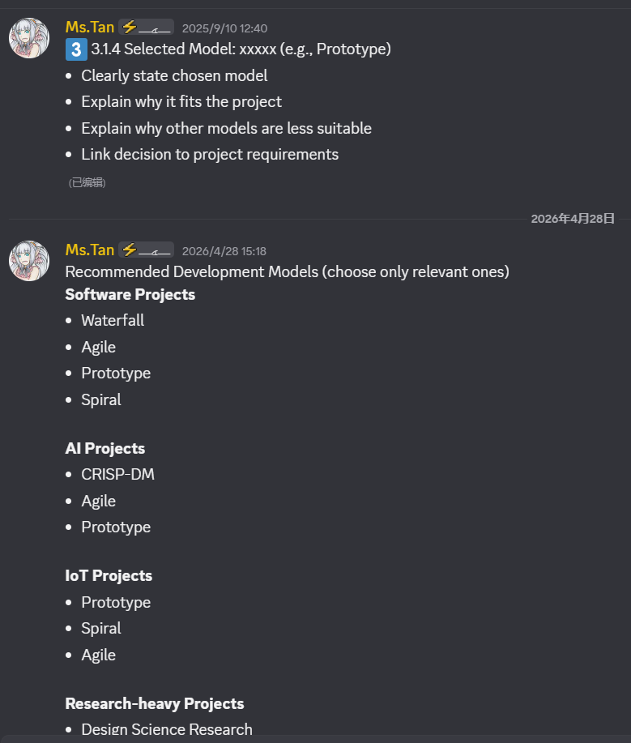
3.2 System Requirements: # ** 0
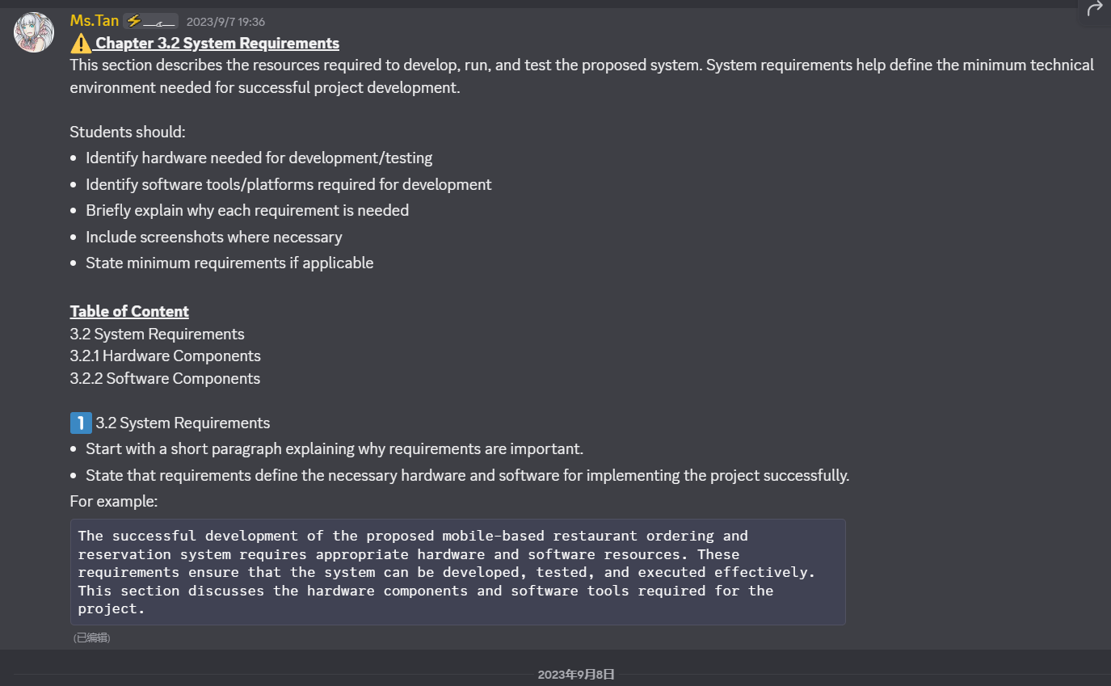
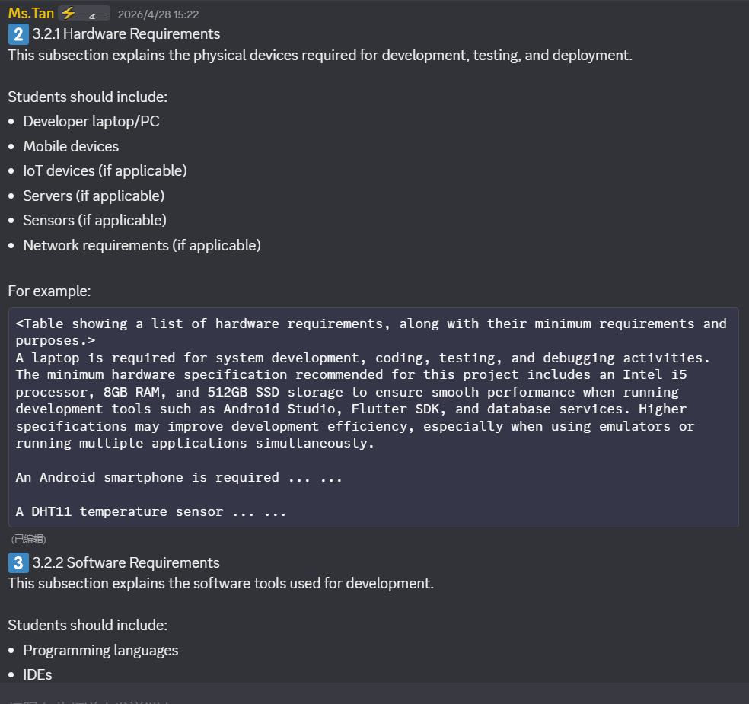
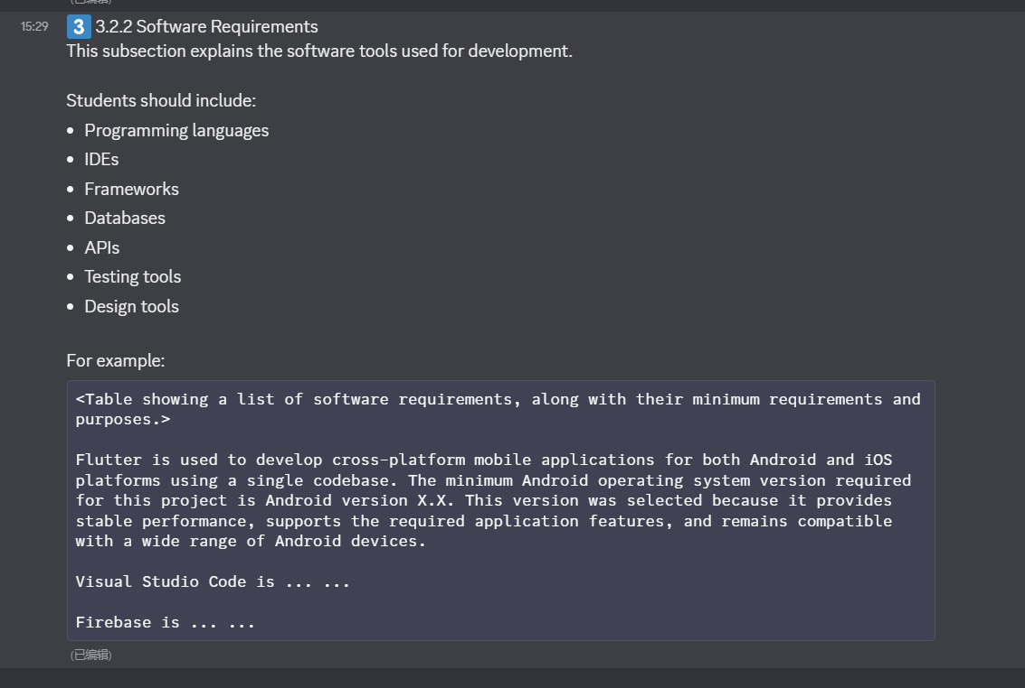
3.3 Functional and Non-Functional Requirements: #
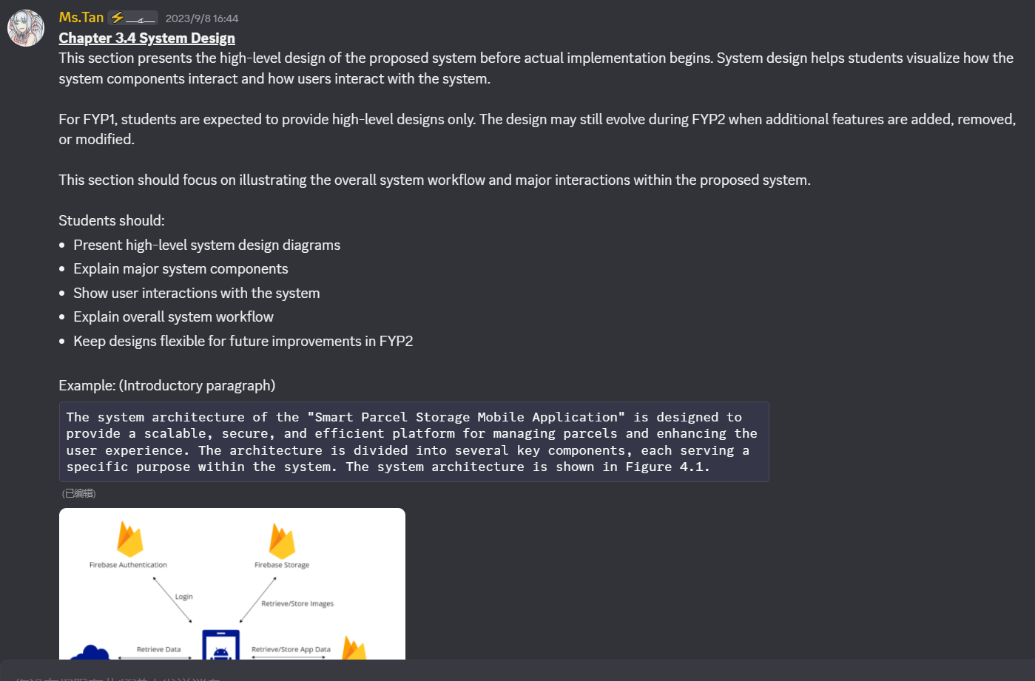
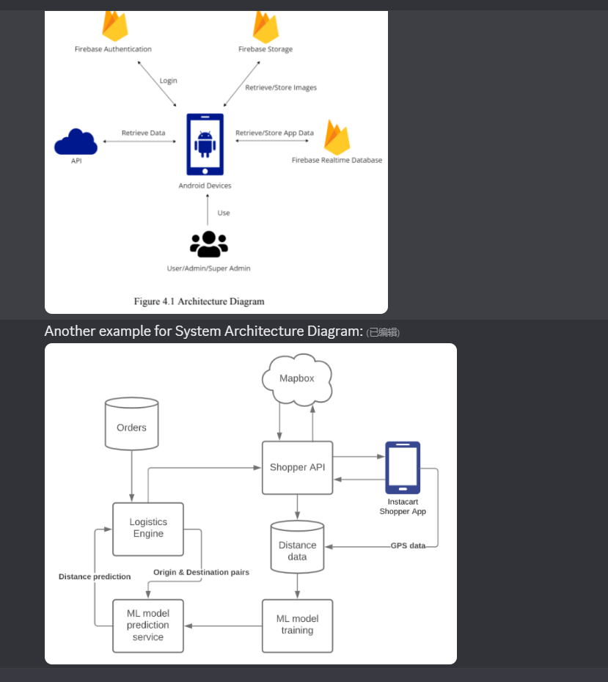
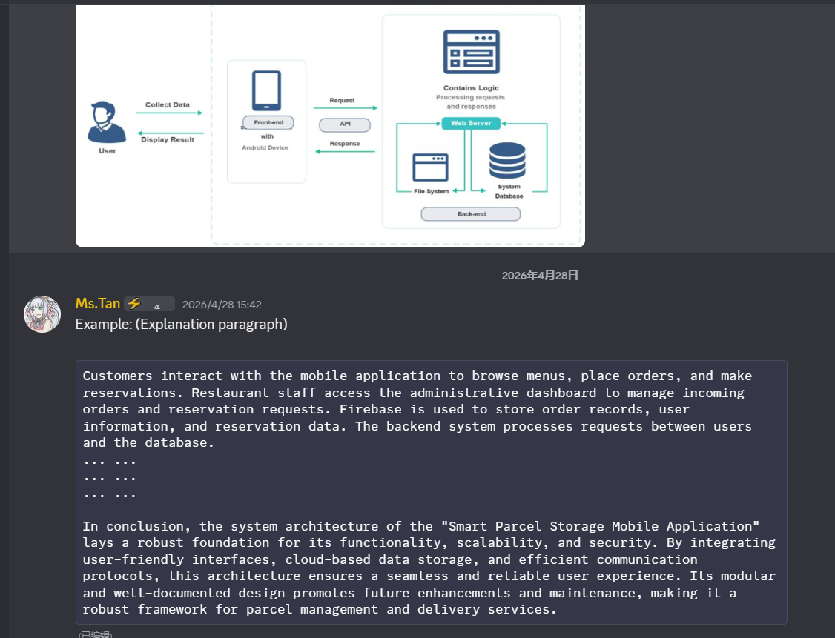
3.4 Project Milestone: w Project Milestone
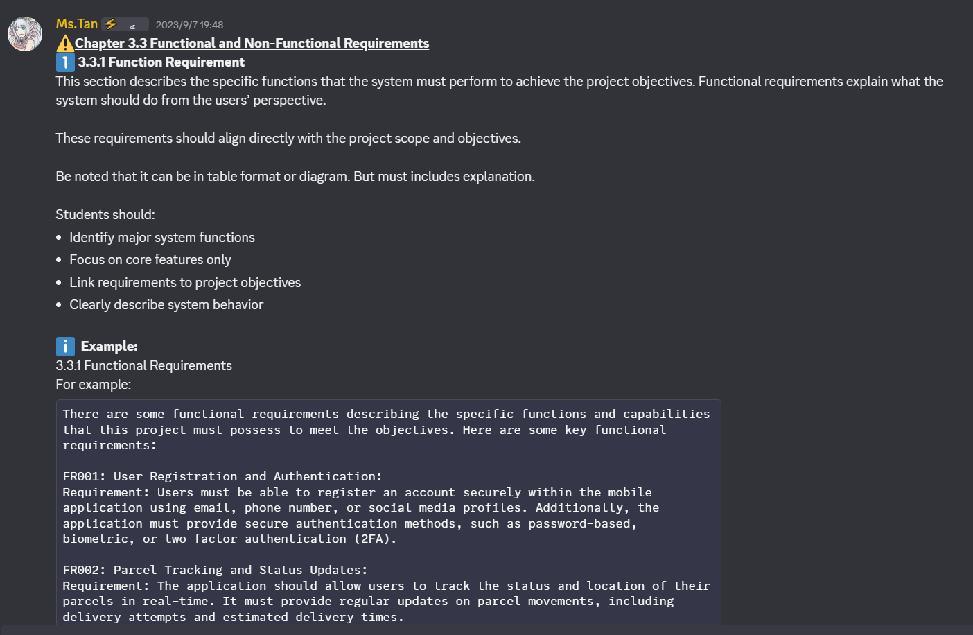
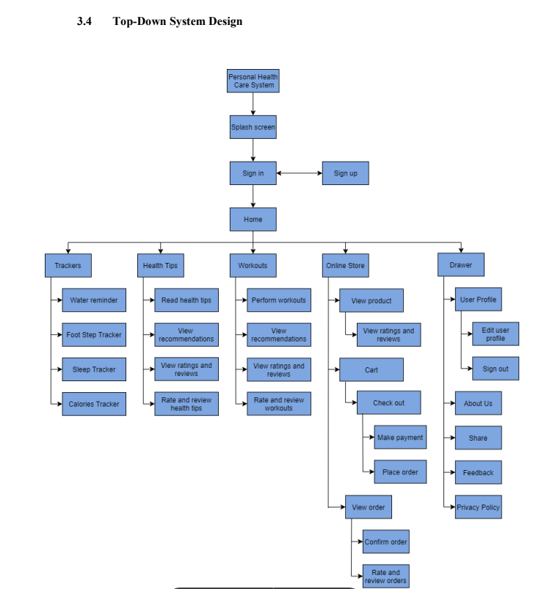
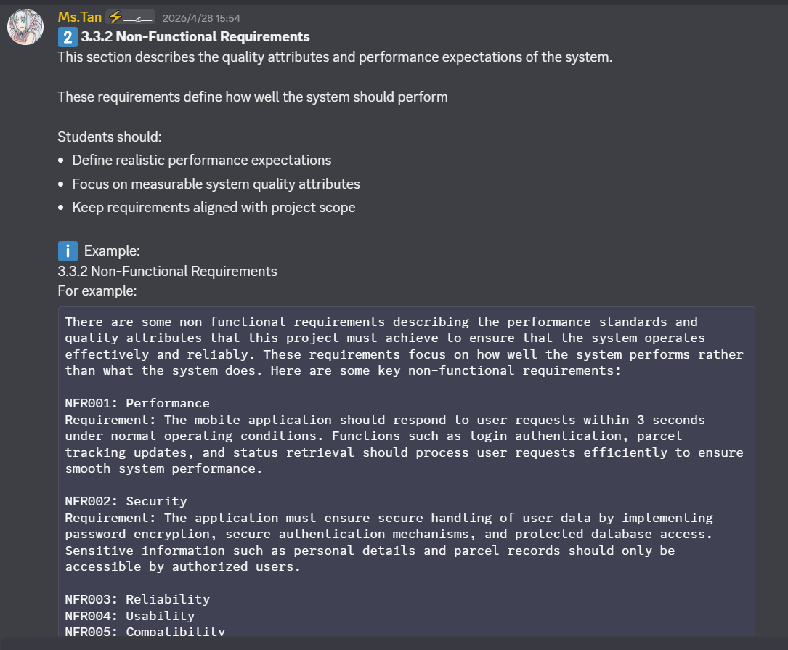
3.4.1 Project I Timeline (With explanation)
3.4.2 Project II Timeline (With explanation)
3.5 Estimated Cost (If no, then said no estimated cost and explain the software that you used are downloadable
from the Internet and required no charge)
3.6 Concluding Remark (Brief summary of the chapter) ()

Chapter 4 - System Design
4.1 System Architecture: # ** 0
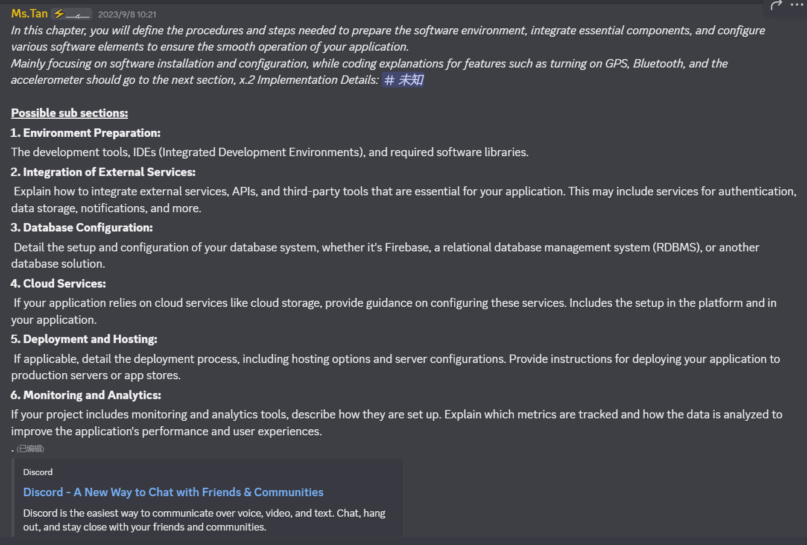
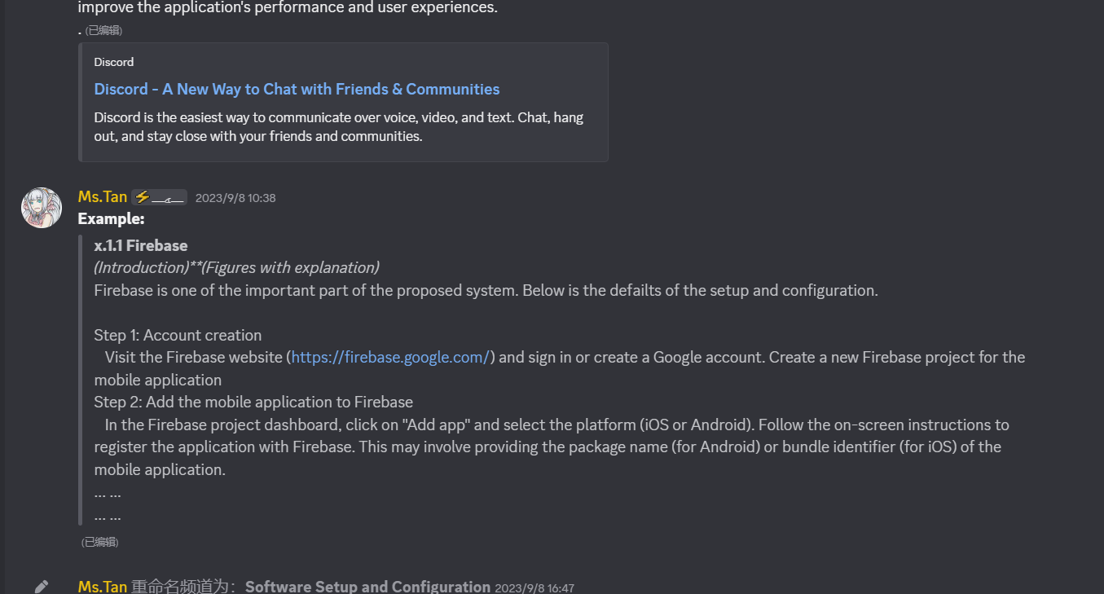
4.2 Use Case Diagram: # ** 0
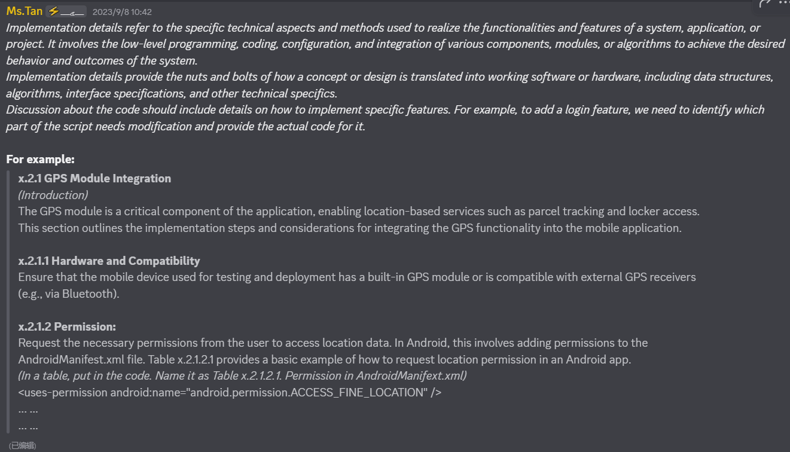
4.3 Activity Diagram: # 未知
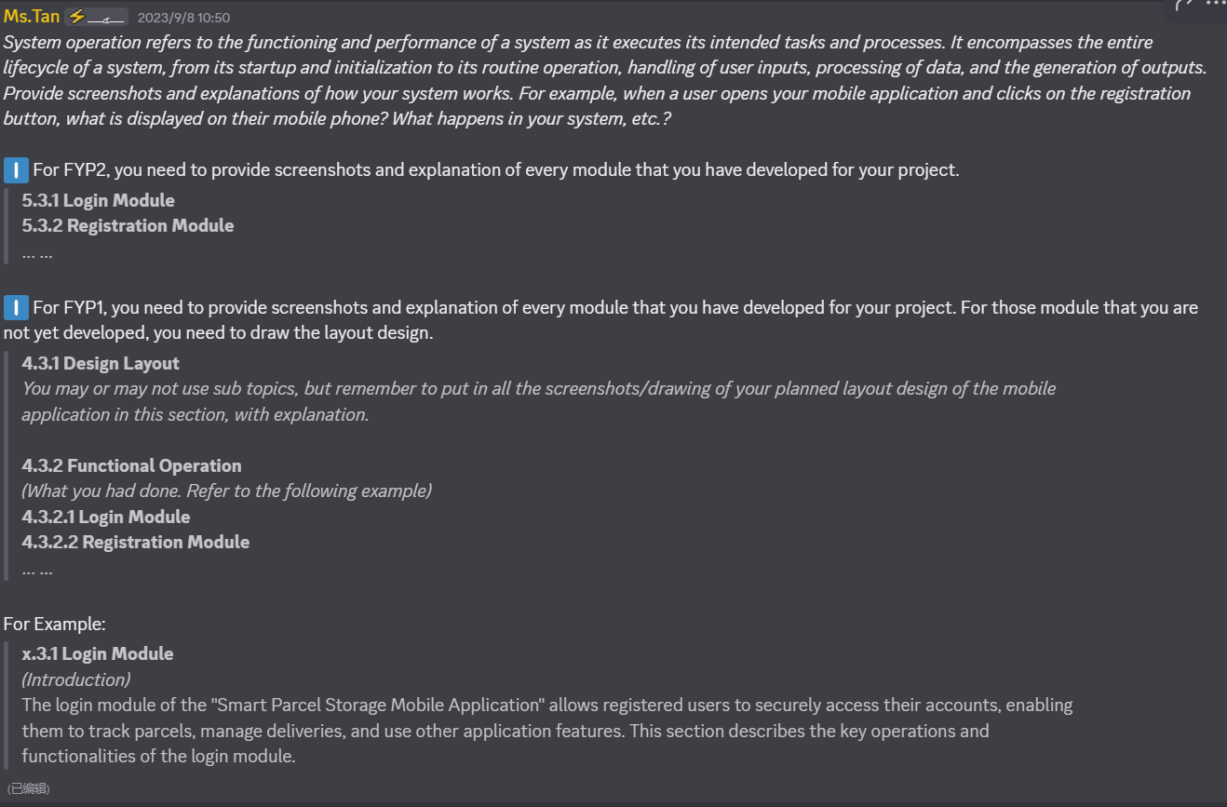
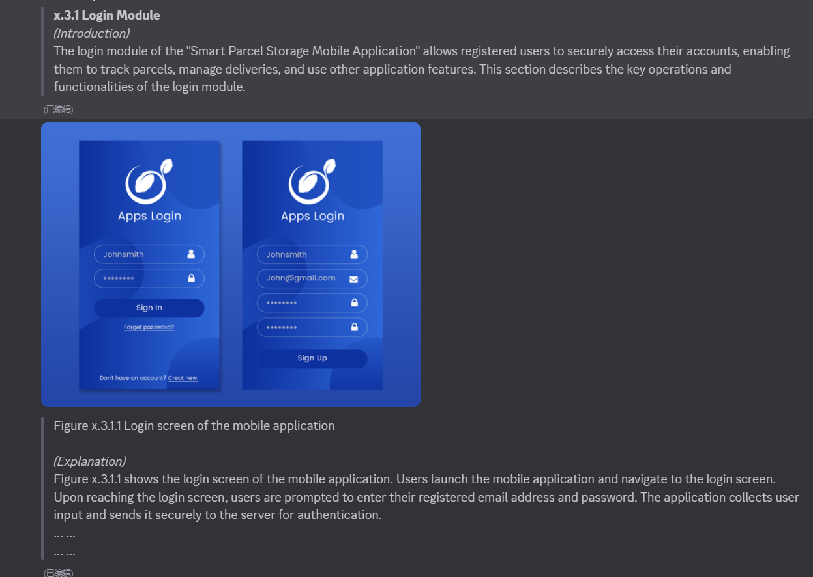
4.4 Database Design: # ** 0
4.5 Concluding Remark ()

Report Template (FYP2)
Chapter 5 - System Implementation
5.1 Software/Hardware Setup and Configuration: # **
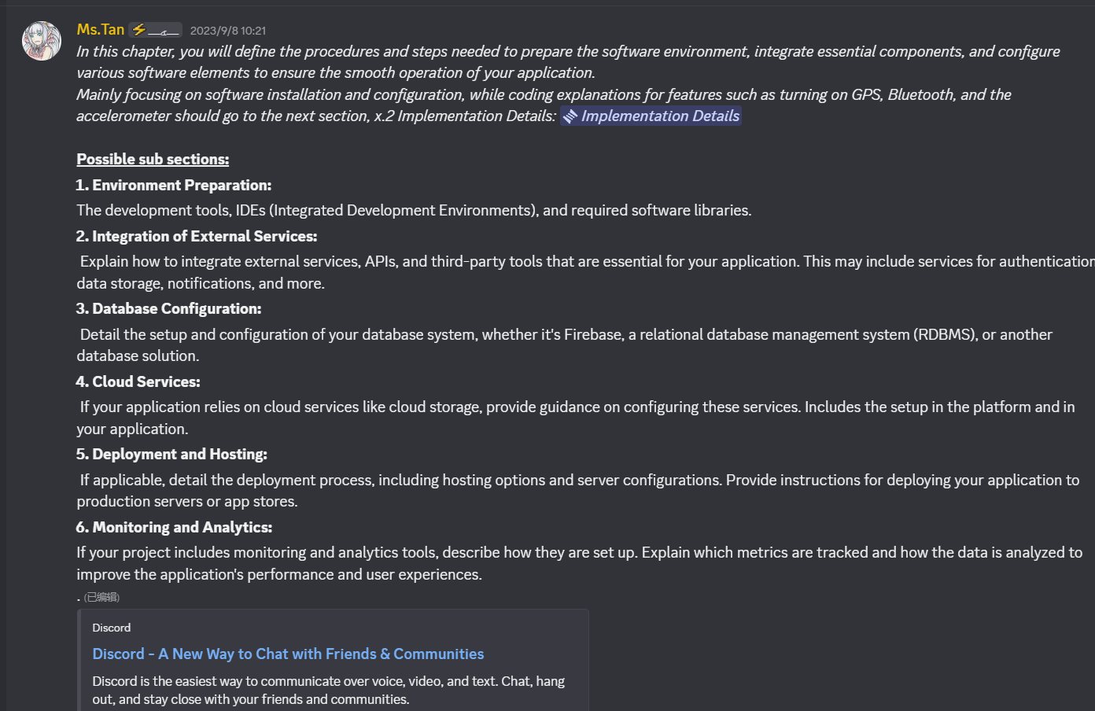
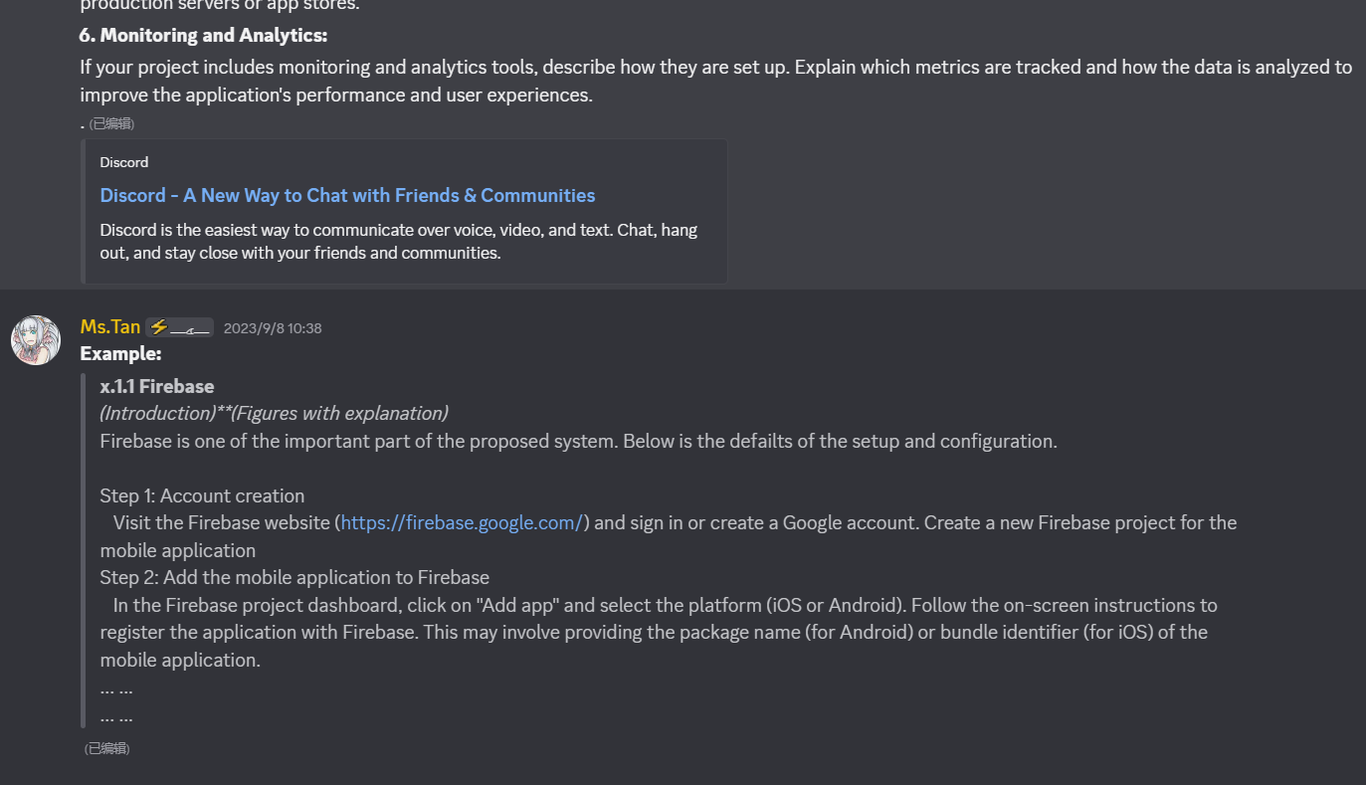
5.2 Implementation Details: # *
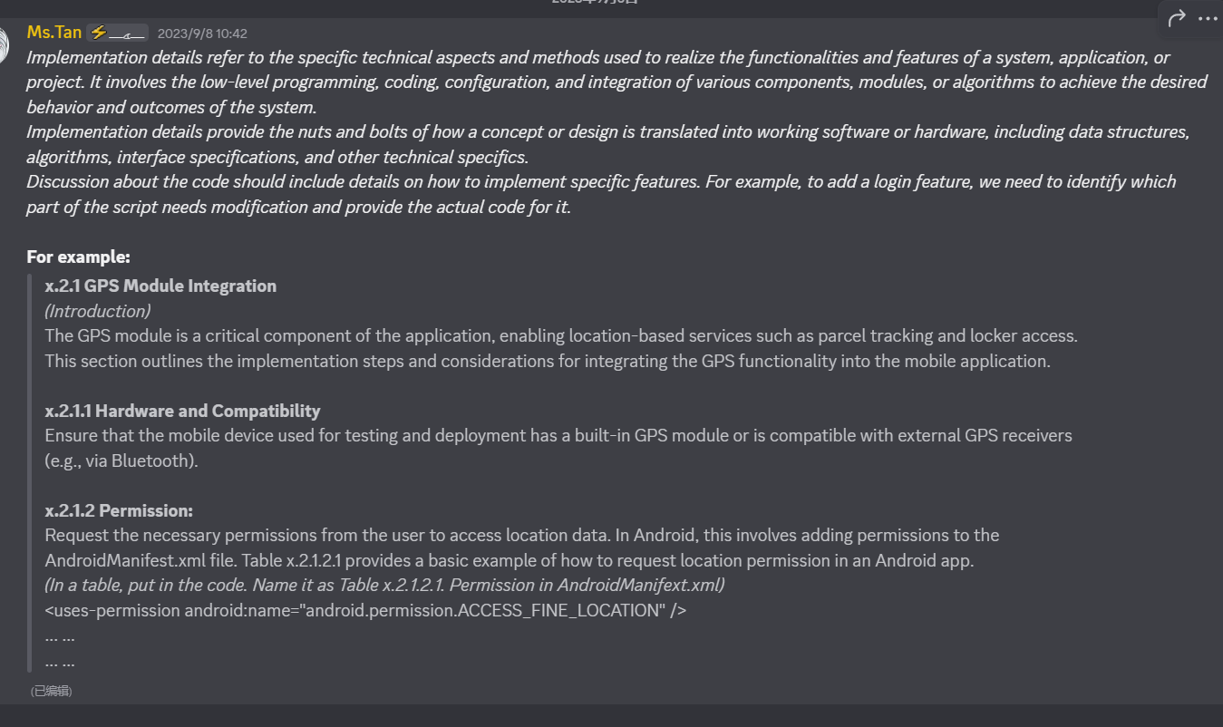
5.3 System Operation: # 未知
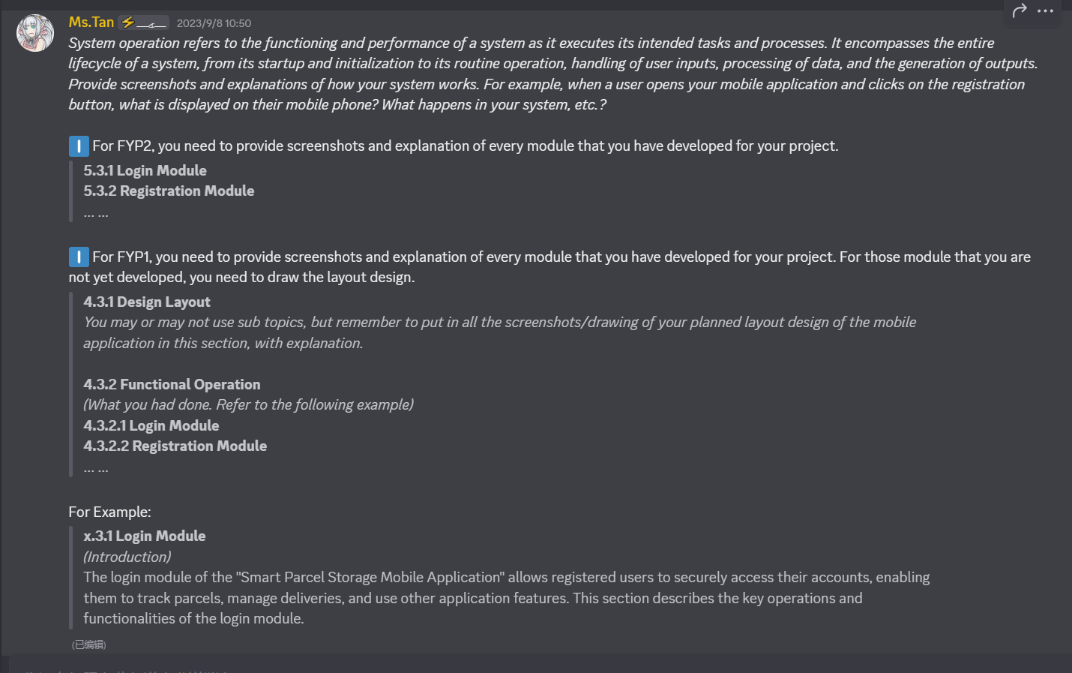
5.4 Concluding Remark ()

Chapter 6 - System Evaluation and Discussion
6.1 System Performance Evaluation: #
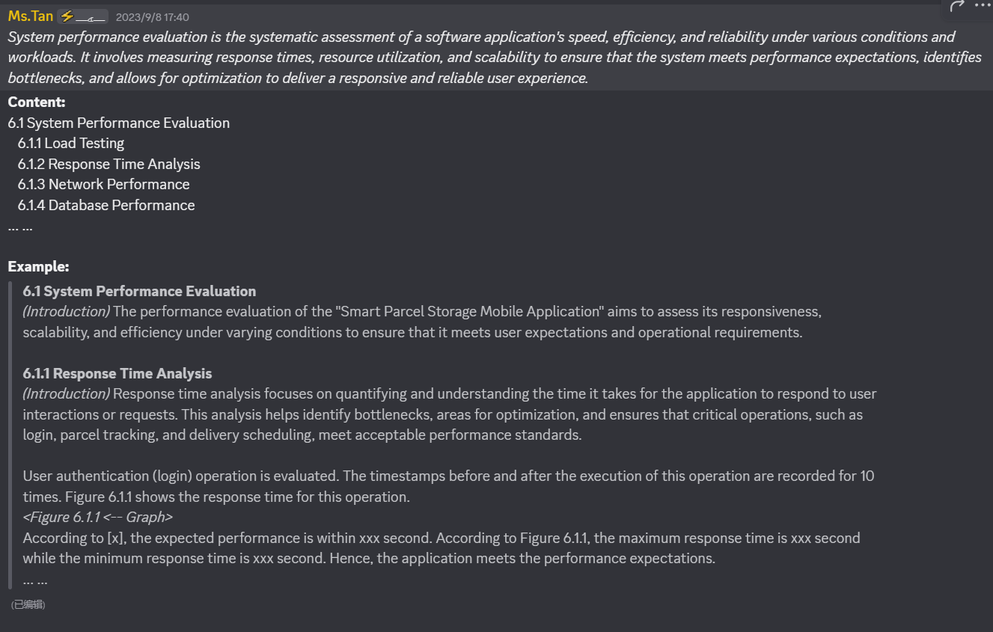
6.2 System Testing Setup and Result: # ** 0
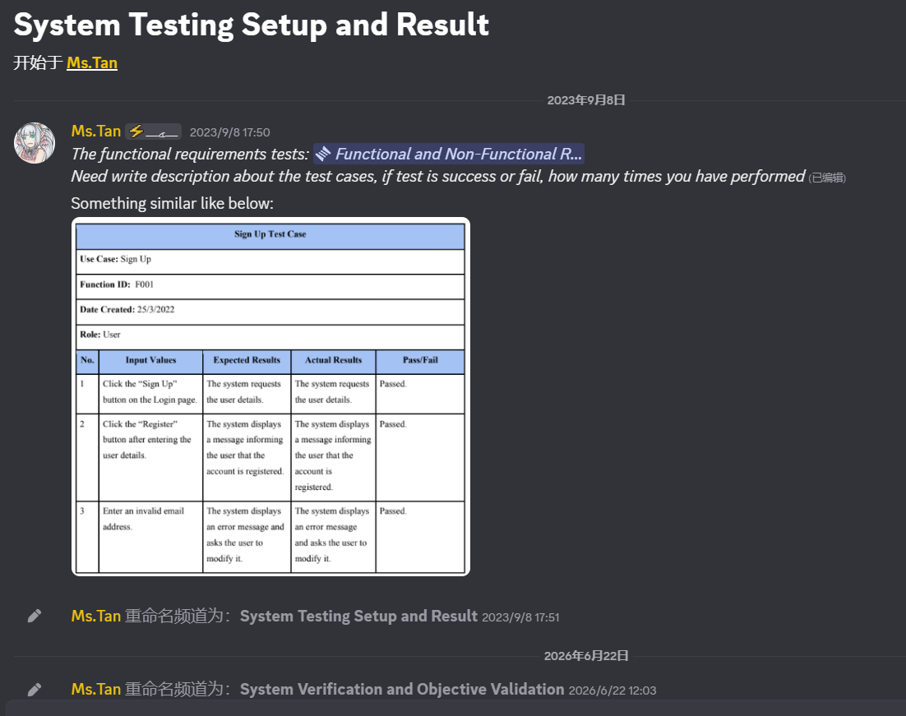
6.2 Questionnaire (If any): # ** 0
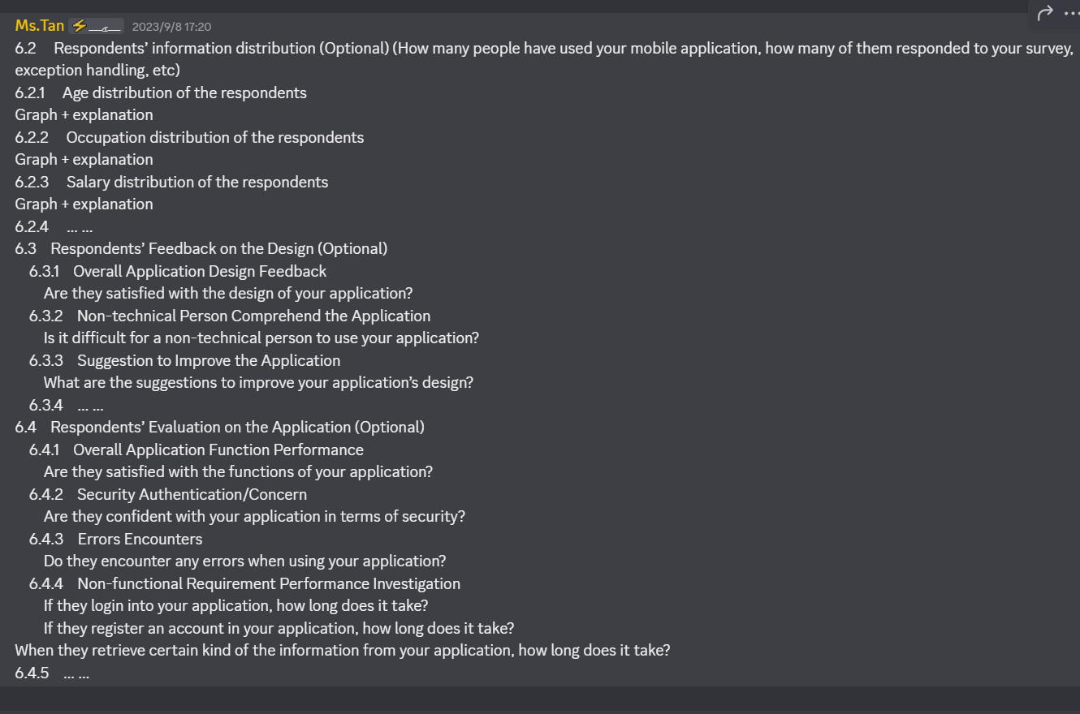
6.3 Project Challenges (If have any)
6.4 Objectives Evaluation (Is your objectives archived? Archived in which way/how to prove it)
6.5 Concluding Remark ()

Chapter 7 - Conclusion and Recommendation
7.1 Conclusion
7.2 Recommendation/Future Work

Appendix
Turnitin & Bi-weekly Report: # faq-report >

